Troop 370

Webmaster

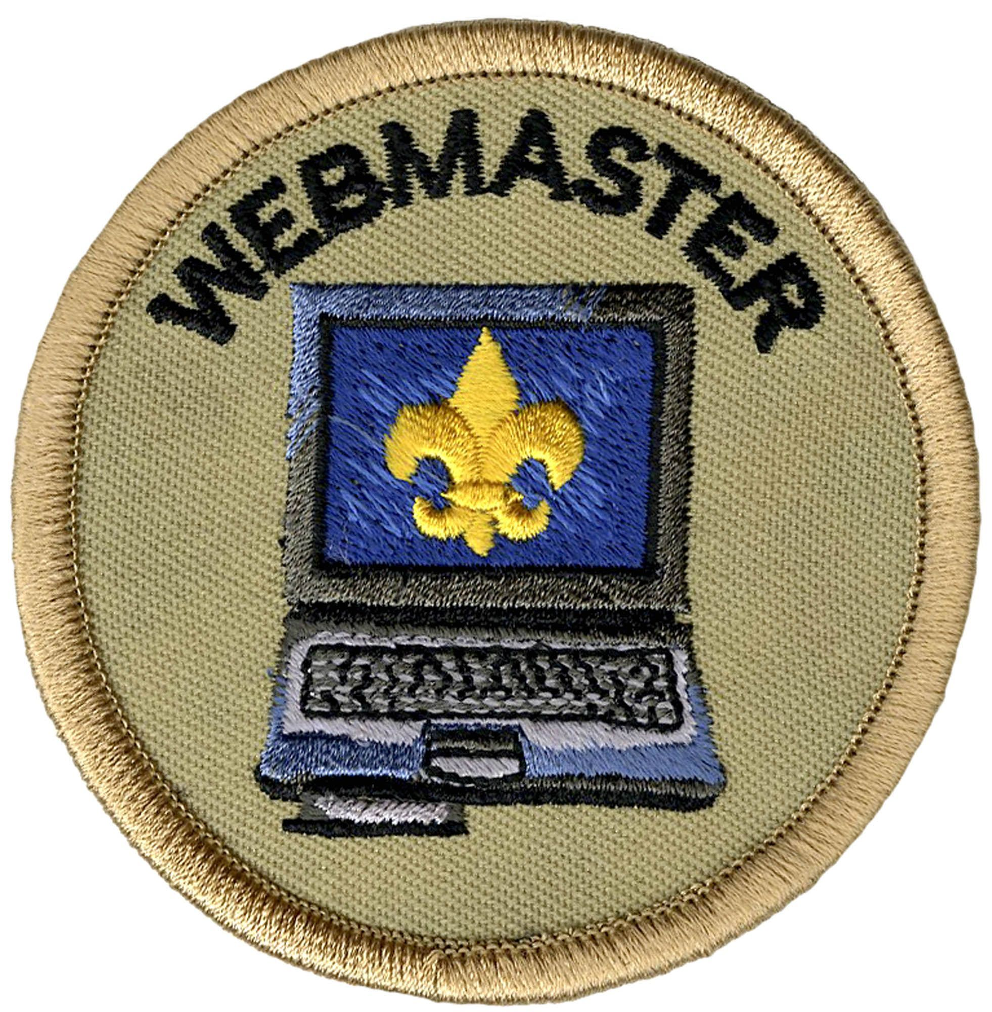

**Job Description**:  
The Webmaster is responsible for maintaining the troop’s website and assisting the Historian with other social media.

**Reports to**: Assistant Senior Patrol Leader  
  
**Webmaster Duties**:

* Maintains a current, safe and secure troop website.
* Ensures the troop website and other social media is a positive reflection of Scouting and Troop 370 for the public.
* Manages the troop’s electronic communication tools including group texts.
* Sets a good example.
* Enthusiastically wears the Scout uniform correctly.
* Lives by the Scout Oath and Law.
* Shows Scout spirit.

**Performance Expectations**

* Expected to give this job your best effort.
* Lead the troop in your assigned functions.
* Conduct assigned activities, responsibilities and duties.
* Receive a positive overall evaluation from the Assistant Senior Patrol Leader.

**Scout's Agreement – General**

I have read the job description for this position. I understand the responsibilities and expectations and will carry them out to the best of my ability.

_____________________________________________ ___________________

(signature)                                                (date)

**Parent's Support Agreement**

I agree with the commitment my son is making. I promise to support him in attending training, troop meetings, and troop activities as well as with encouragement at home. I realize that once selected his presence is necessary for the smooth functioning of the troop.

_______________________________________ ___________________

(signature)                                                (date)